Task 8
Handwritten Digit Recognition Using Neural Networks

Aim:
To build a backpropagation neural network using the MNIST dataset to classify handwritten digits (0–9) and to analyze how the network extracts features from image data.

Algorithm:
- Import required libraries such as TensorFlow, NumPy, and Matplotlib.
- Load the MNIST dataset for training and testing.
- Normalize the image pixel values to the range 0 to 1.
- Define the neural network architecture with input, hidden, and output layers.
- Initialize weights and biases for all layers.
- Perform forward propagation to compute the output.
- Calculate the loss using a suitable loss function.
- Apply backpropagation to update weights and minimize error.
- Train the model for multiple epochs and validate performance.
- Evaluate the model on test data and analyze feature extraction from hidden layers.
Program:
# ----------------------------------------
# HANDWRITTEN DIGIT CLASSIFICATION + FEATURE ANALYSIS (FIXED)
# ----------------------------------------

!pip install tensorflow matplotlib

import tensorflow as tf
from tensorflow.keras import layers, models
import matplotlib.pyplot as plt
import numpy as np

# ----------------------------------------
# 1. LOAD MNIST DATASET
# ----------------------------------------
(X_train, y_train), (X_test, y_test) = tf.keras.datasets.mnist.load_data()

# Normalize
X_train = X_train / 255.0
X_test = X_test / 255.0

# ----------------------------------------
# 2. BUILD MODEL (FIXED INPUT LAYER)
# ----------------------------------------
model = models.Sequential([
layers.Input(shape=(28, 28)),
layers.Flatten(),
layers.Dense(128, activation='relu'),
layers.Dense(64, activation='relu'),
layers.Dense(10, activation='softmax')
])

model.compile(
optimizer='adam',
loss='sparse_categorical_crossentropy',
metrics=['accuracy']
)

# ----------------------------------------
# 3. TRAIN
# ----------------------------------------
history = model.fit(X_train, y_train, epochs=5, validation_split=0.1)

# ----------------------------------------
# 4. EVALUATE
# ----------------------------------------
test_loss, test_acc = model.evaluate(X_test, y_test)
print("\nTest Accuracy:", test_acc)

# ----------------------------------------
# 5. PREDICTION
# ----------------------------------------
index = 0
prediction = model.predict(X_test[index].reshape(1,28,28))

print("\nPredicted Digit:", np.argmax(prediction))
print("Actual Digit:", y_test[index])

plt.imshow(X_test[index], cmap='gray')
plt.title("Test Image")
plt.show()

# ----------------------------------------
# 6. FEATURE EXTRACTION (FIXED)
# ----------------------------------------

# Force model to build (important for safety)
_ = model.predict(X_test[:1])

# Create feature extraction model
feature_model = tf.keras.Model(
inputs=model.inputs,
outputs=model.layers[2].output # First hidden layer
)

feature_output = feature_model.predict(X_test[0].reshape(1,28,28))

print("\nFeature Vector Shape:", feature_output.shape)
print("First 10 Feature Values:", feature_output[0][:10])

# ----------------------------------------
# 7. ACCURACY GRAPH
# ----------------------------------------
plt.plot(history.history['accuracy'])
plt.plot(history.history['val_accuracy'])
plt.title('Model Accuracy')
plt.xlabel('Epoch')
plt.ylabel('Accuracy')
plt.legend(['Train', 'Validation'])
plt.show()

Output:

Epoch 1/5
1688/1688 ━━━━━━━━━━━━━━━━━━━━ 6s 3ms/step - accuracy: 0.9259 - loss: 0.2522 - val_accuracy: 0.9687 - val_loss: 0.1102
Epoch 2/5
1688/1688 ━━━━━━━━━━━━━━━━━━━━ 5s 3ms/step - accuracy: 0.9664 - loss: 0.1087 - val_accuracy: 0.9722 - val_loss: 0.0876
Epoch 3/5
1688/1688 ━━━━━━━━━━━━━━━━━━━━ 5s 3ms/step - accuracy: 0.9762 - loss: 0.0751 - val_accuracy: 0.9732 - val_loss: 0.0879
Epoch 4/5
1688/1688 ━━━━━━━━━━━━━━━━━━━━ 4s 3ms/step - accuracy: 0.9821 - loss: 0.0570 - val_accuracy: 0.9747 - val_loss: 0.0813
Epoch 5/5
1688/1688 ━━━━━━━━━━━━━━━━━━━━ 5s 3ms/step - accuracy: 0.9868 - loss: 0.0423 - val_accuracy: 0.9788 - val_loss: 0.0729
313/313 ━━━━━━━━━━━━━━━━━━━━ 1s 2ms/step - accuracy: 0.9783 - loss: 0.0773

Test Accuracy: 0.9782999753952026
1/1 ━━━━━━━━━━━━━━━━━━━━ 0s 69ms/step

Predicted Digit: 7
Actual Digit: 7
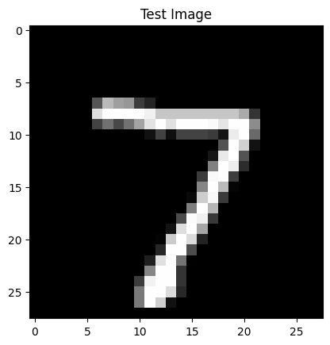
1/1 ━━━━━━━━━━━━━━━━━━━━ 0s 51ms/step
1/1 ━━━━━━━━━━━━━━━━━━━━ 0s 69ms/step

Feature Vector Shape: (1, 64)
First 10 Feature Values: [0.1703091 0.62267184 0. 0. 2.7603035 0.
1.3490673 3.3116927 5.0548906 1.7823068 ]
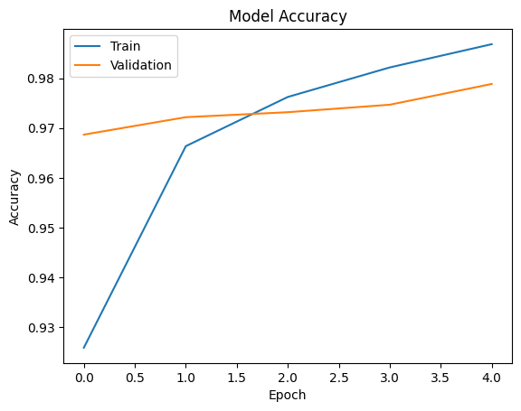
Result:
The backpropagation neural network was successfully implemented using the MNIST dataset.

